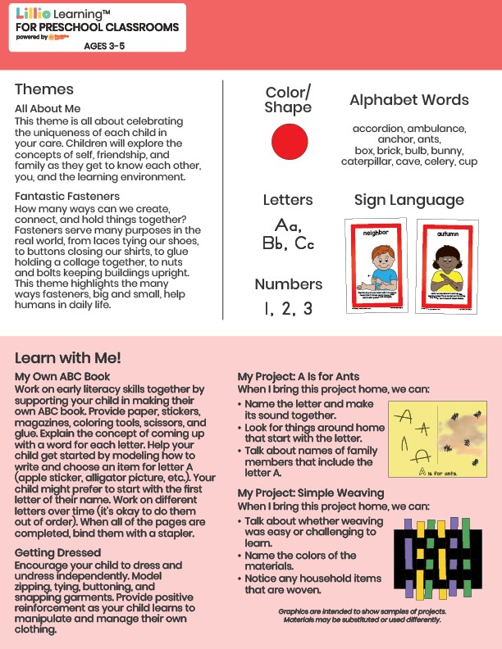­

September 2024

Newsletter

Add Your Name/Logo Here

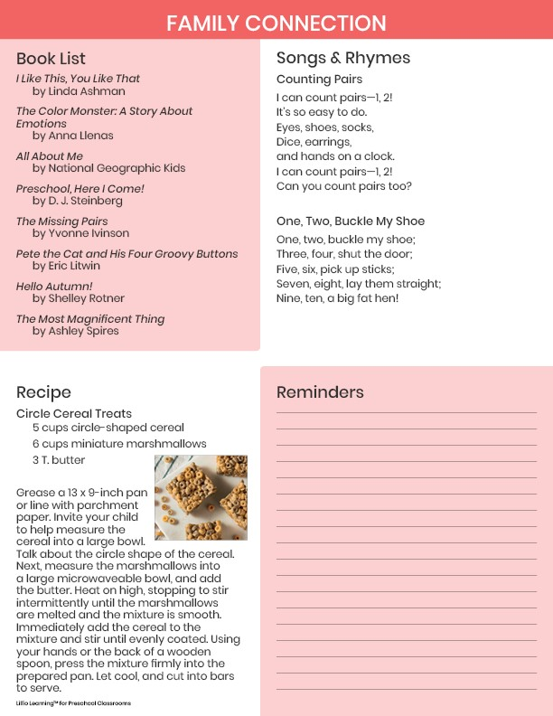

Add Notes